**THE ULTIMATE GUIDE TO USING THE UMBUY ANDROID**

**Note:** To run the application you will be provided secret.xml by the professor

Add the secret.xml file under

umbuy -> project/umbuy -> mobile -> app -> src -> main -> res -> values -> <add the secret.xml file here>

**The Login Page**

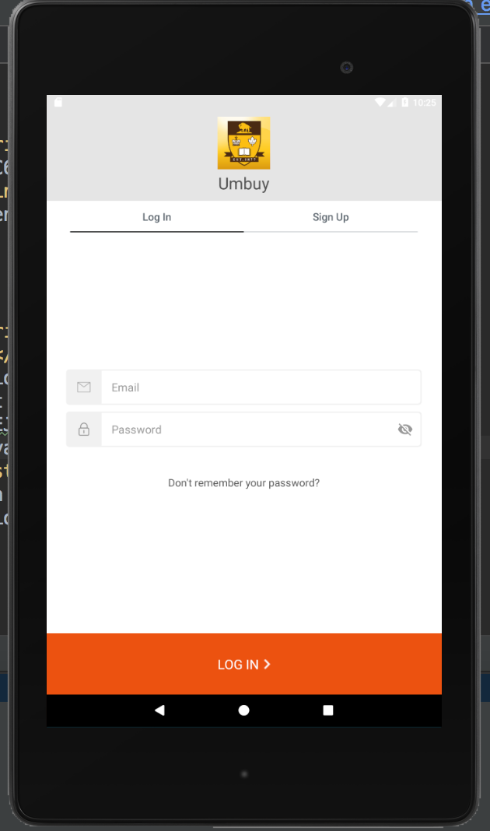

**The Sign-up Page**

**Fill in the Sign-up email and password**

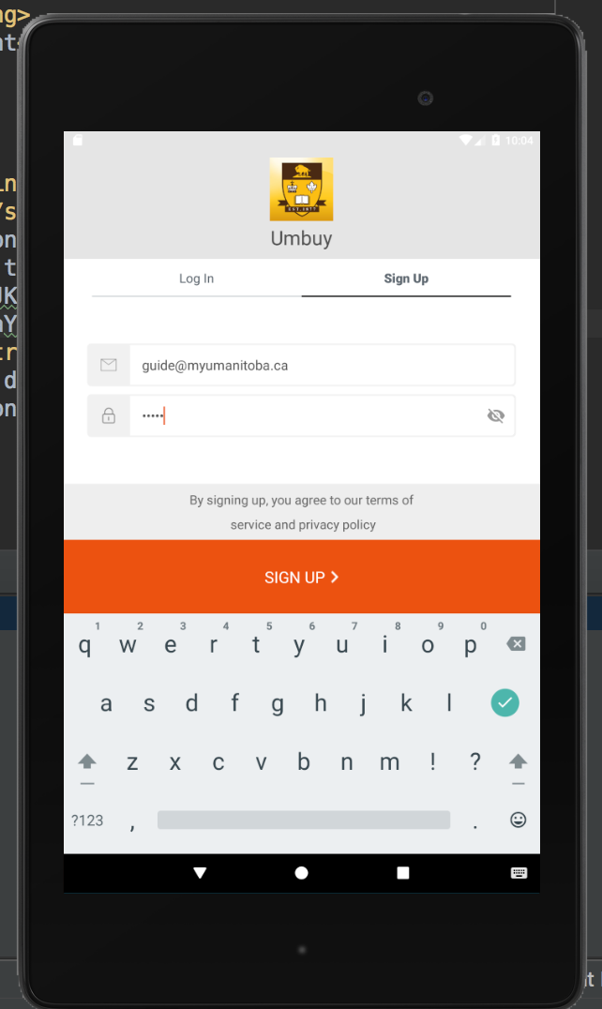

**Add FirstName, LastName and Phone number**

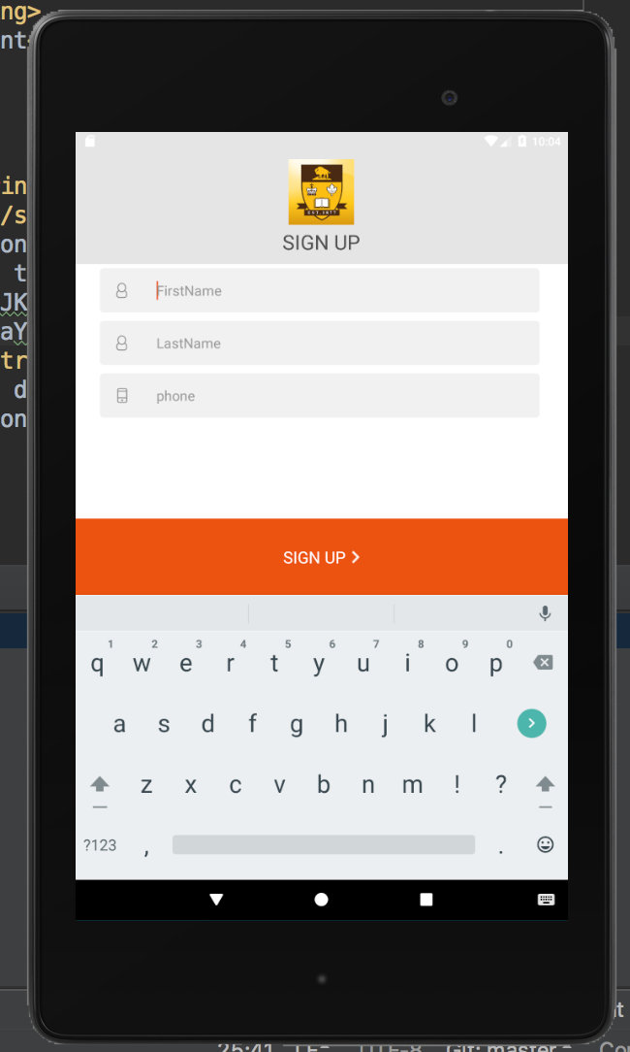

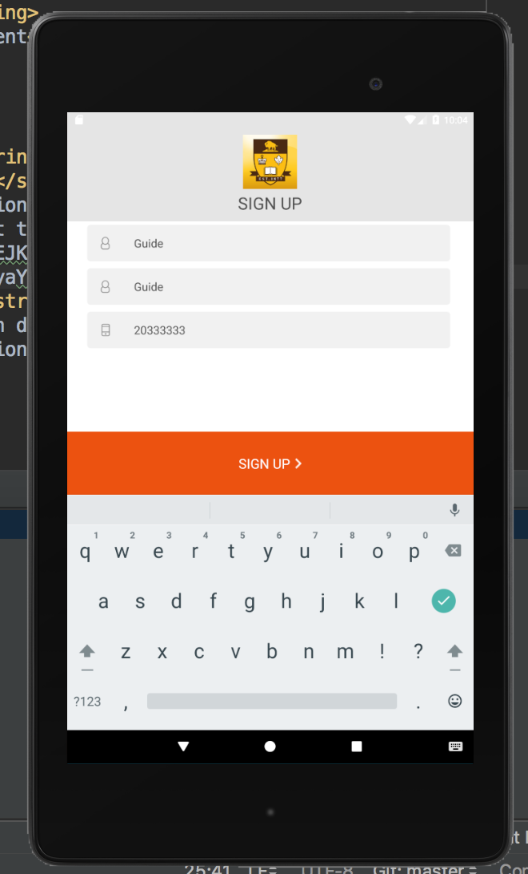

**Main Ads page (also the Home Page) shows up after one has signed up (redirect to main ads page after sign up)**

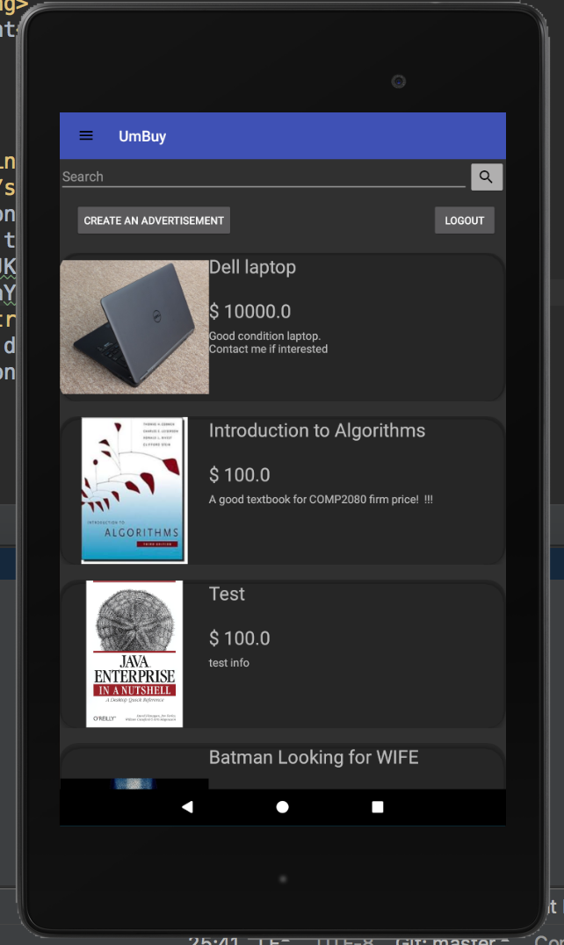

**After one clicks on any specific ad. The information page about the ad shows up**

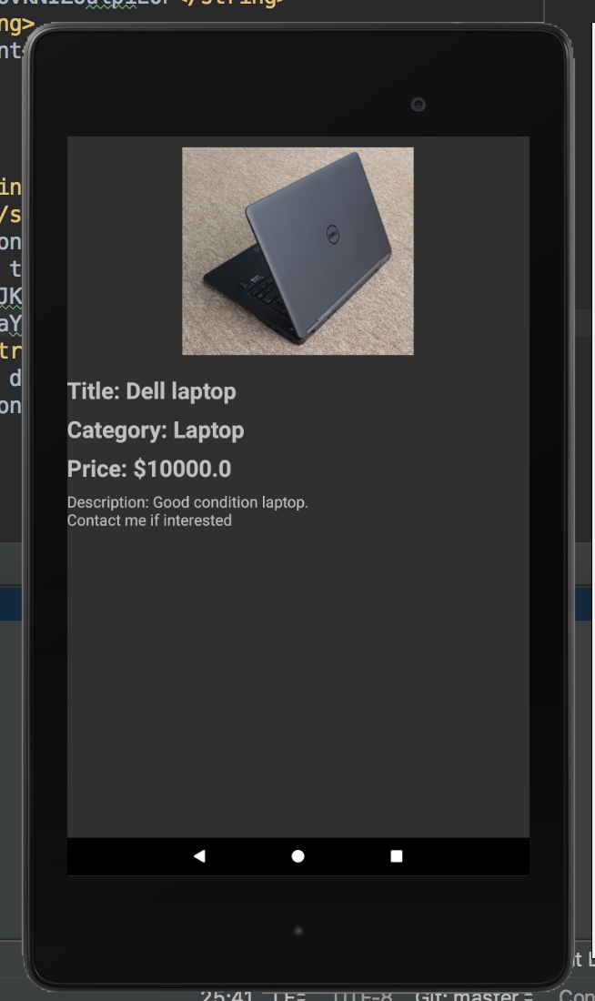

**Type anything in the search bar and press the Search icon square button to the right of the input area to get the results. One can use part of the key words of the item title to get the appropriate ads**

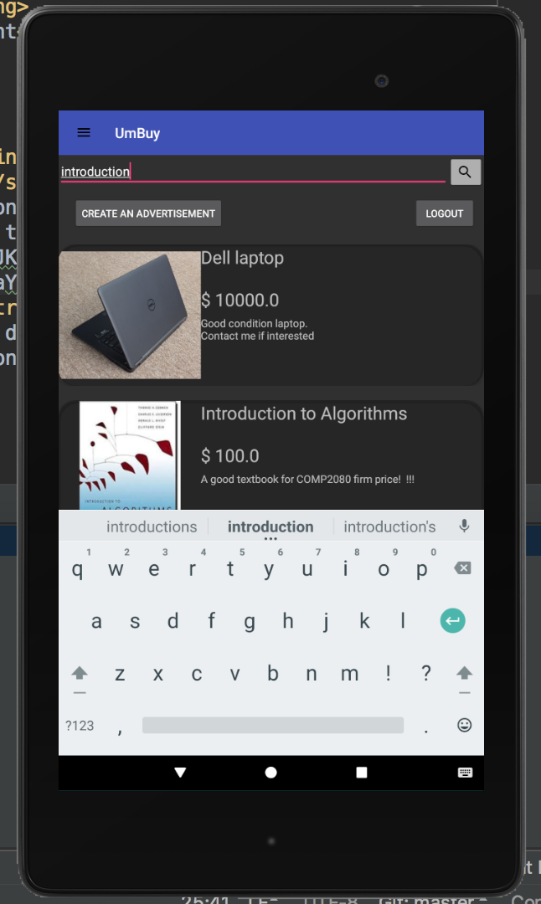

**Get the of the ad search after clicking on the square search icon button after typing the input in the search bar**

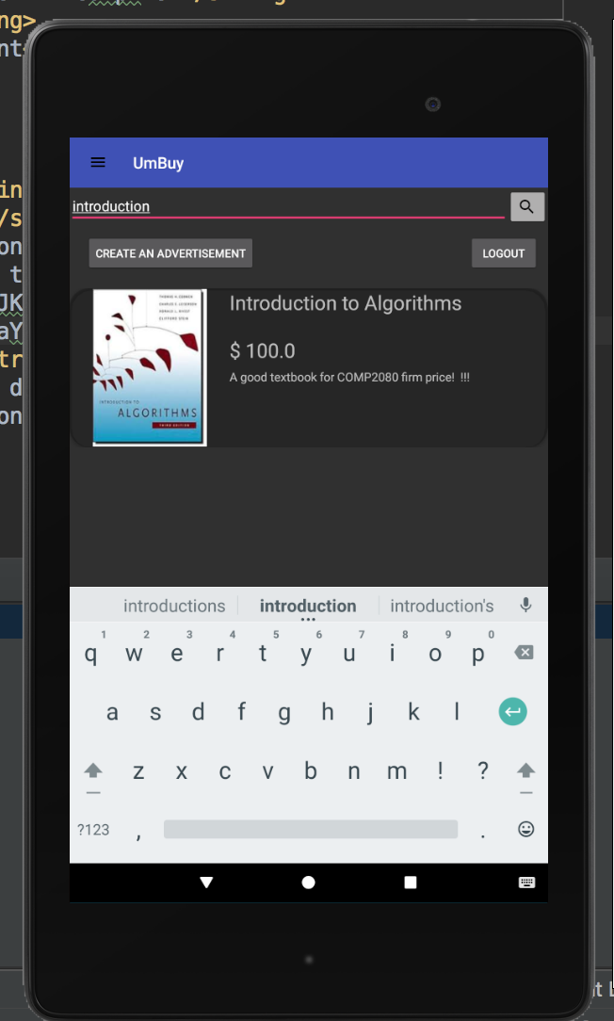

**Click on the “Create An Advertisement” button to create an ad. The following page shows up after one has clicked on the “Create An Advertisement” button.**

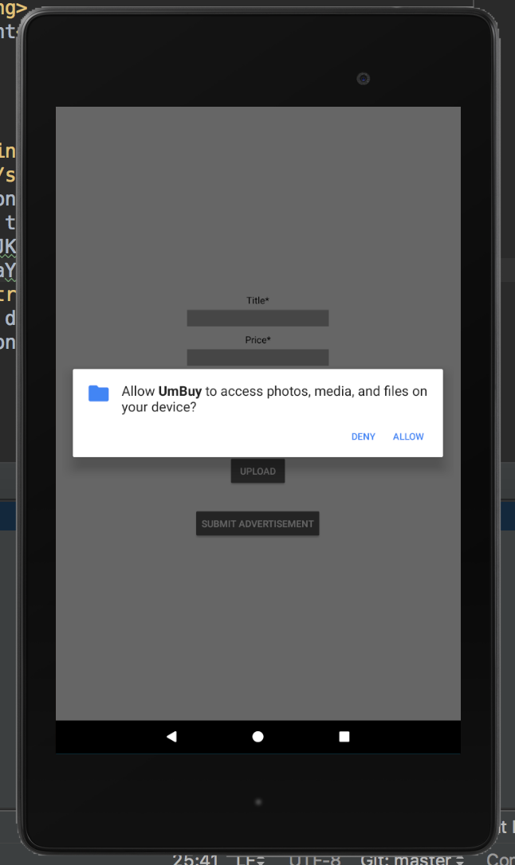

**Give permission to the device’s media and files particularly for photos. One can post an ad without uploading a photo too.**

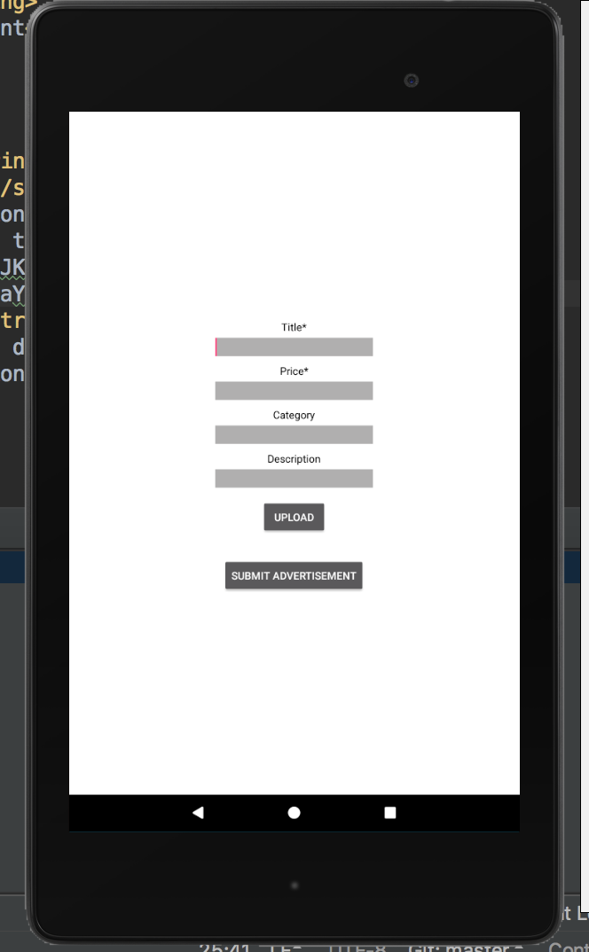

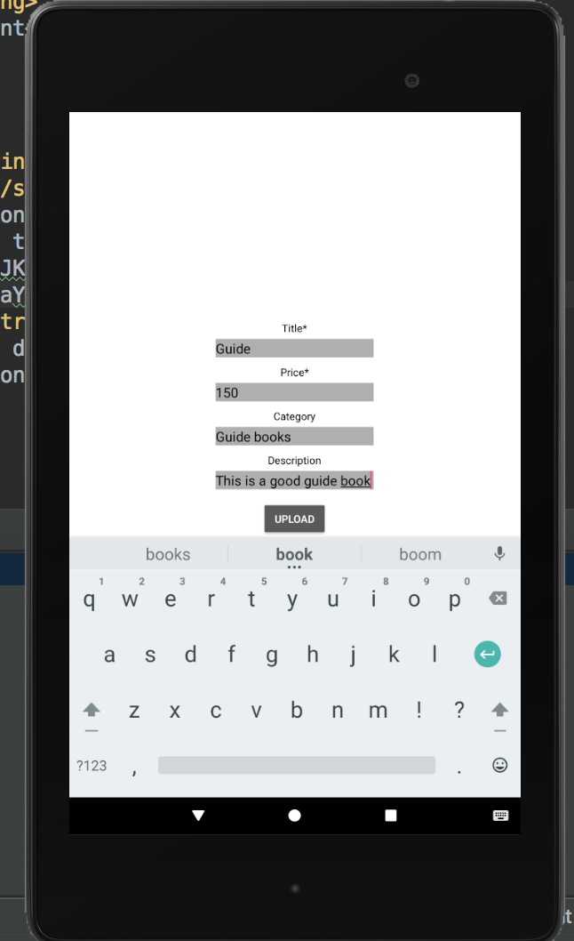

**Fill in the ad details**

**Click on the upload button to post an ad**

**If you click on upload button, it would give you an option to select from the gallery or photos. If you don’t have a pic, that’s cool too**

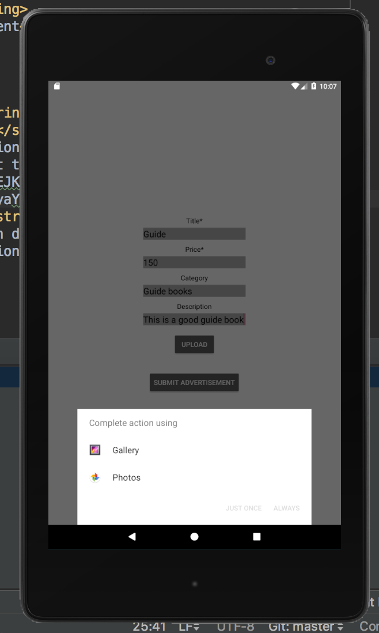

**Scroll and find your ad posted on the Main Ads Page (also called Home)!**

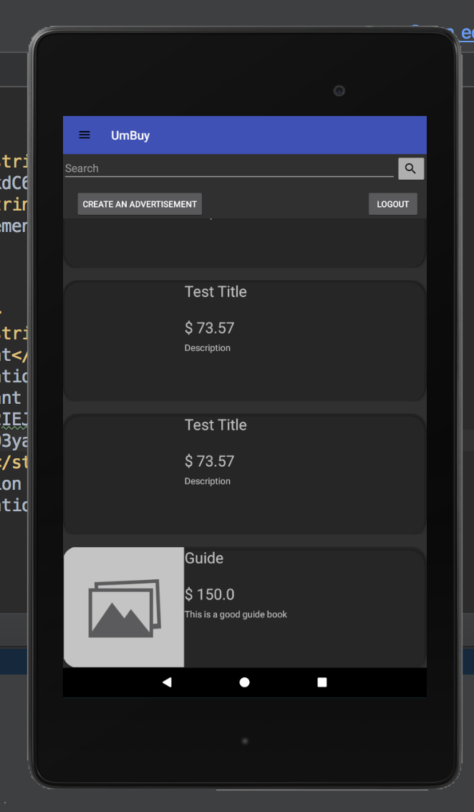

**Click on the Ad that you created (i.e “Guide” in this case)**

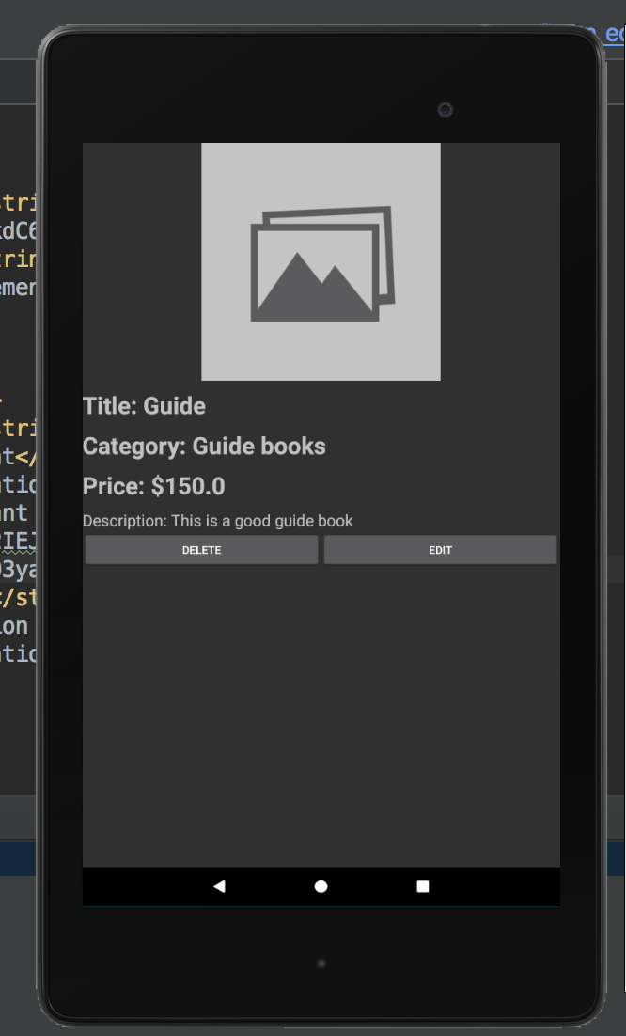

**Note: you can see the delete and the edit button since you are the owner of the ad and can delete it**

**Lets try clicking on the edit button**

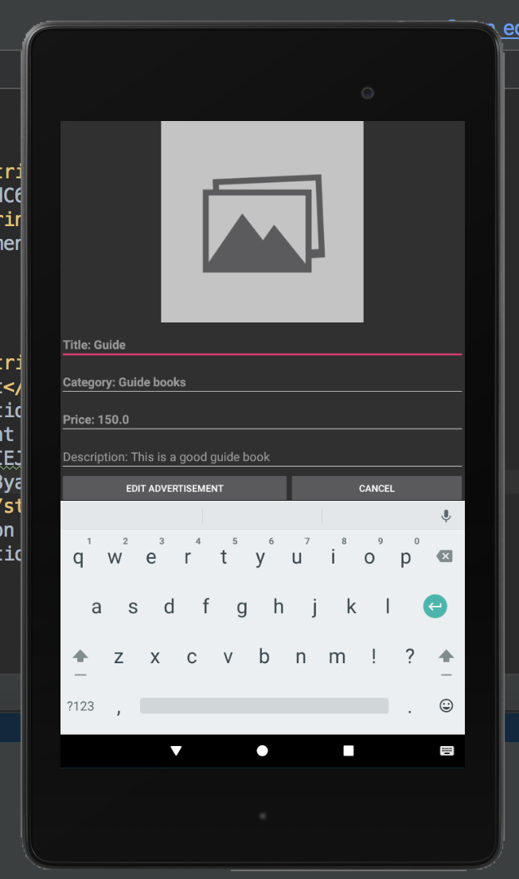

**Let’s edit the title to “Guide again” from “Guide” and click on Edit Advertisement after that**

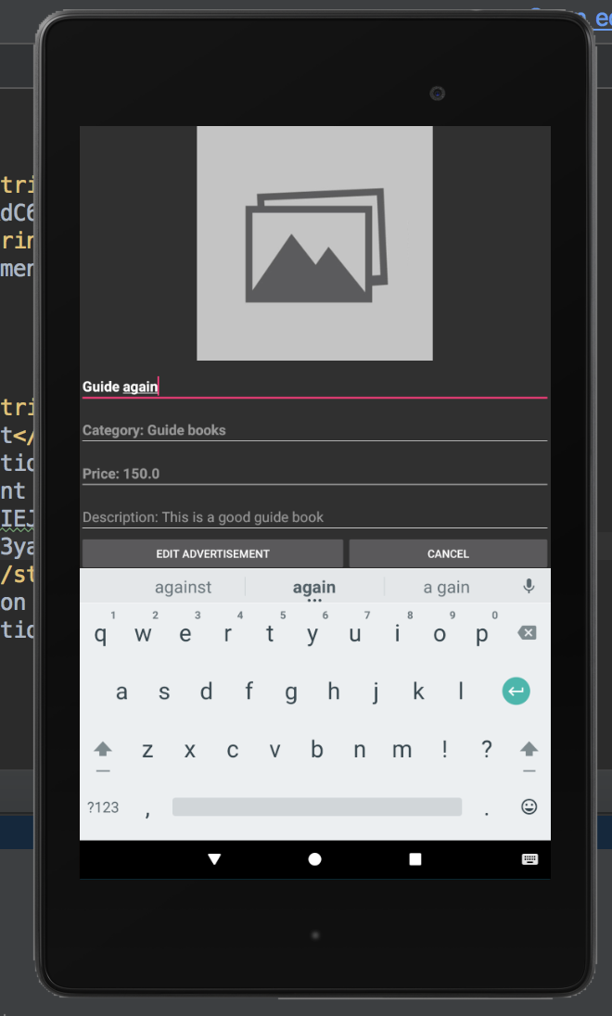

**Note: you can change other details of the ads too**

**Now we have the new edited ad named “Guide again”**

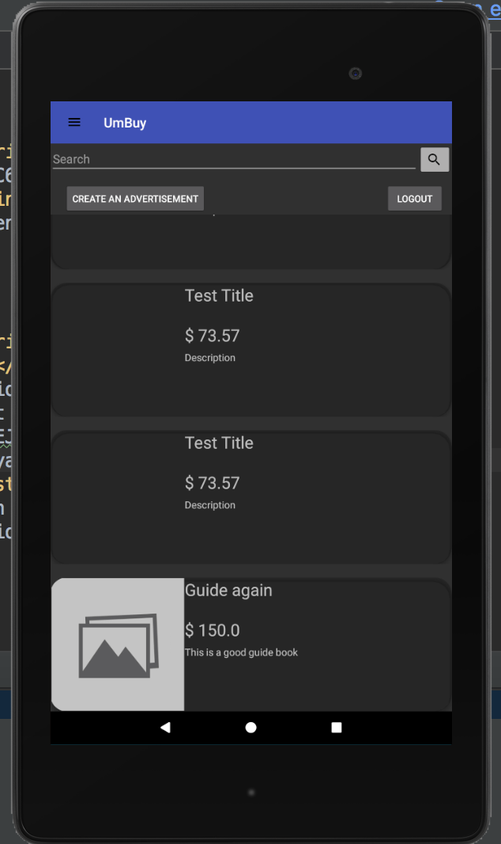

**../../../Screen%20Shot%202018-03-23%20at%205.58.14%20PM.png**

**You can click on the navigation drawer**

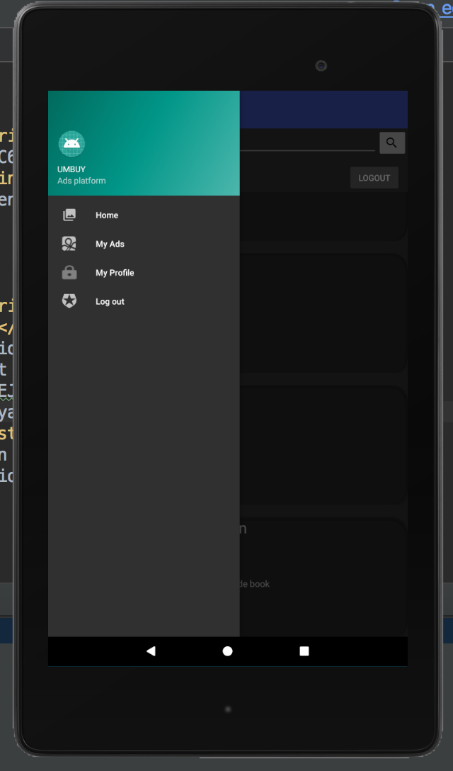

**Note: You can also swipe from left to right to get the navigation drawer**

**Click on MyAds from the navigation bar**

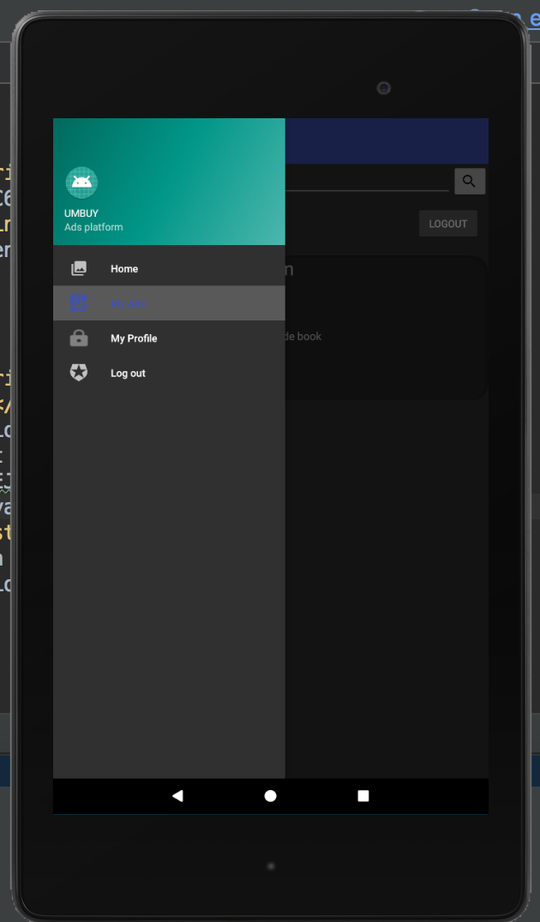

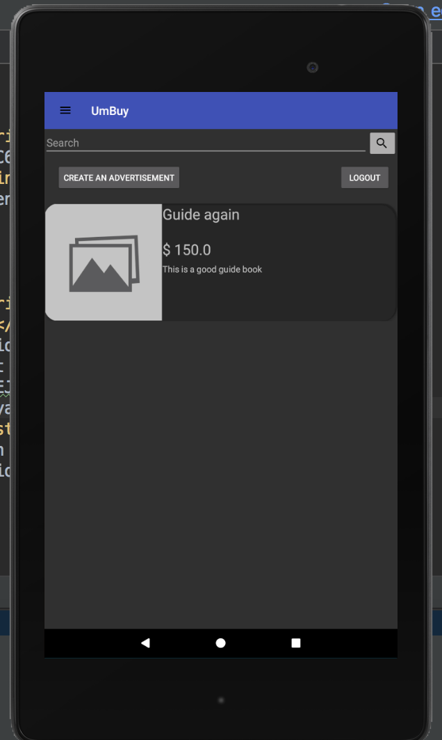

**See the ads that you posted. You can click on each of the ads and delete or even edit them as shown below**

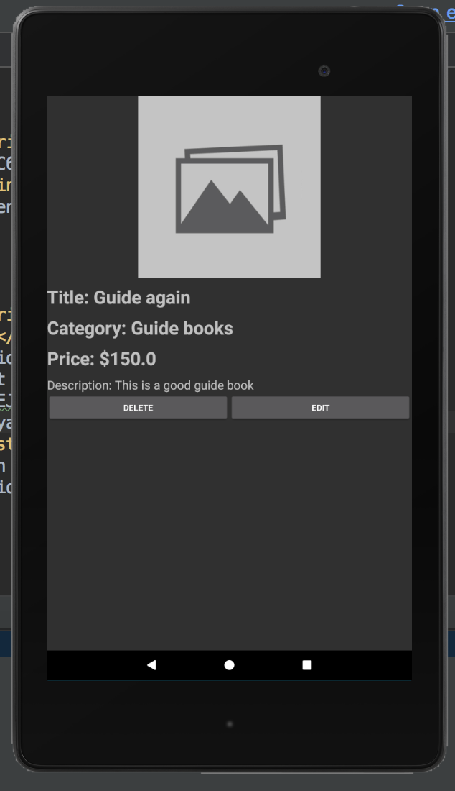

**../../../Screen%20Shot%202018-03-23%20at%205.58.14%20PM.pngYou can click on the navigation drawer**

**And select My Profile**



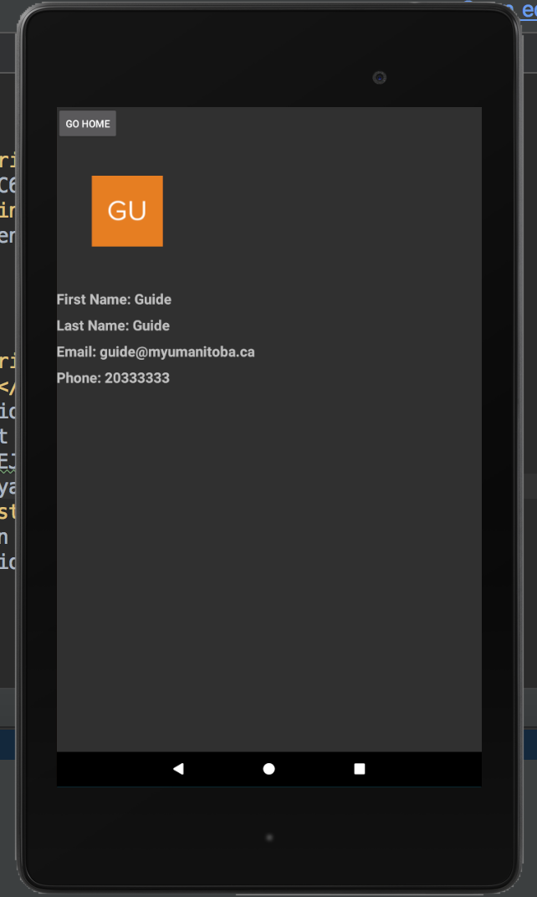

**To go back to the main ads page, click on the Go Home button**

**To Log Out: you can click on the Log Out button at any time from the navigation bar or the button that says “Log Out” (Main Ads Page or MyAds Page or the navigation bar).**

**This will end the session and redirect the user to the Login Page again. One can login back by filling in the login details again.**

